2 times table workbook
1
2
3
4
5
6
7
8
9
10
11
12
=
$$×$$
Name:
Class:
Date started:
Trace over the 2 times tables

0 x 2 = 0 | 7 x 2 = 14
1 x 2 = 2 | 8 x 2 = 16
2 x 2 = 4 | 9 x 2 = 18
3 x 2 = 6 | 10 x 2 = 20
4 x 2 = 8 | 11 x 2 = 22
5 x 2 = 10 | 12 x 2 = 24
6 x 2 = 12

Shade in all the numbers from the 2 times table

1 | 2 | 3 | 4 | 5 | 6 | 7 | 8 | 9 | 10
11 | 12 | 13 | 14 | 15 | 16 | 17 | 18 | 19 | 20
21 | 22 | 23 | 24 | 25 | 26 | 27 | 28 | 29 | 30
31 | 32 | 33 | 34 | 35 | 36 | 37 | 38 | 39 | 40
41 | 42 | 43 | 44 | 45 | 46 | 47 | 48 | 49 | 50
51 | 52 | 53 | 54 | 55 | 56 | 57 | 58 | 59 | 60
61 | 62 | 63 | 64 | 65 | 66 | 67 | 68 | 69 | 70
71 | 72 | 73 | 74 | 75 | 76 | 77 | 78 | 79 | 80
81 | 82 | 83 | 84 | 85 | 86 | 87 | 88 | 89 | 90
91 | 92 | 93 | 94 | 95 | 96 | 97 | 98 | 99 | 100
Now write them out in order

Fill in the missing answers

0 x 2 = 0 | 7 x 2 =
1 x 2 = | 8 x 2 =
2 x 2 = | 9 x 2 =
3 x 2 = | 10 x 2 =
4 x 2 = | 11 x 2 =
5 x 2 = | 12 x 2 =
6 x 2 =

Write out the 2 times table in order

0 x 2 = 0 | x =
x = | x =
x = | x =
x = | x =
x = | x =
x = | x =
x =

Fill in the answers to the 2 times table

1 x 2 =
4 x 2 =
2 x 2 =
3 x 2 =
7 x 2 =
5 x 2 =
6 x 2 =
10 x 2 =
12 x 2 =
11 x 2 =
9 x 2 =
8 x 2 =

Match the sum to the answer
0 x 2 |  | 12
1 x 2 |  | 22
2 x 2 |  | 6
3 x 2 |  | 0
4 x 2 |  | 18
5 x 2 |  | 16
6 x 2 |  | 4
7 x 2 |  | 24
8 x 2 |  | 2
9 x 2 |  | 8
10 x 2 |  | 14
11 x 2 |  | 10
12 x 2 |  | 20

Match the sum to the answer
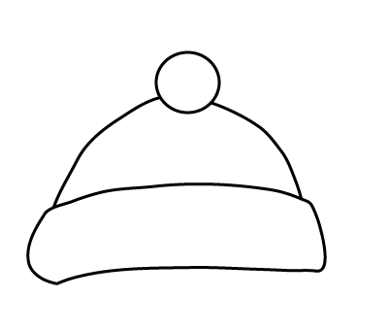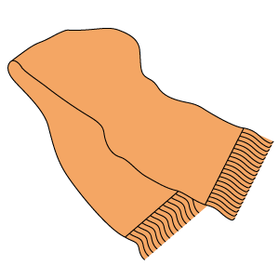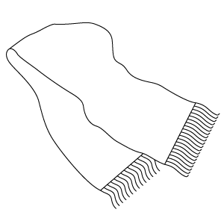
2
10
0
8
6
24
4
1 x 2 =
2 x 2 =
3 x 2 =
4 x 2 =
5 x 2 =
6 x 2 =
7 x 2 =
8 x 2 =
9 x 2 =
10 x 2 =
11 x 2 =
12 x 2 =
14
16
22
20
18
12
0 x 2 =

Fill in the missing answers

x 2
0
2
1
5
8
7
4
9
6
12
3
11
10
0
Fill in the answers

10 x 2 = | 5 x 2 =
3 x 2 = | 7 x 2 =
9 x 2 = | 12 x 2 =
11 x 2 = | 2 x 2 =
6 x 2 = | 1 x 2 =
0 x 2 = | 4 x 2 =
8 x 2 =

Look at the answers
Complete the sum

^{1.} 1 | x | 2 | = | 2
 |  |  |  |  | ^{2.} | x | 2 | = | 18
 |  | ^{3.} | x | 2 | = | 22
^{4.} |  |  |  |  |  |  | ^{5.} |  | ^{6.}
x |  | ^{7.} | x | 2 | = | 24 | x |  | x
2 |  |  |  |  |  |  | 2 |  | 2
= | ^{8.} | x | 2 | = | 0 |  | = |  | =
12 | ^{9.} |  | ^{10.} |  |  |  | 6 |  | 20
 | x |  | x
 | 2 |  | 2 |  | ^{11.} | x | 2 | = | 14
 | = |  | =
 | 4 |  | 8 |  | ^{12.} | x | 2 | = | 10
 |  | ^{13.} | x | 2 | = | 16

